Project Design Phase – II

Technology Stack (Architecture & Stack)

Date: | 19 Feb 2026
Team ID: | LTVIP2026TMIDS24563
Project Name: | Deep Learning Fundus Image Analysis for Early Detection of Diabetic Retinopathy
Maximum Marks: | 5 Marks
Technical Architecture:
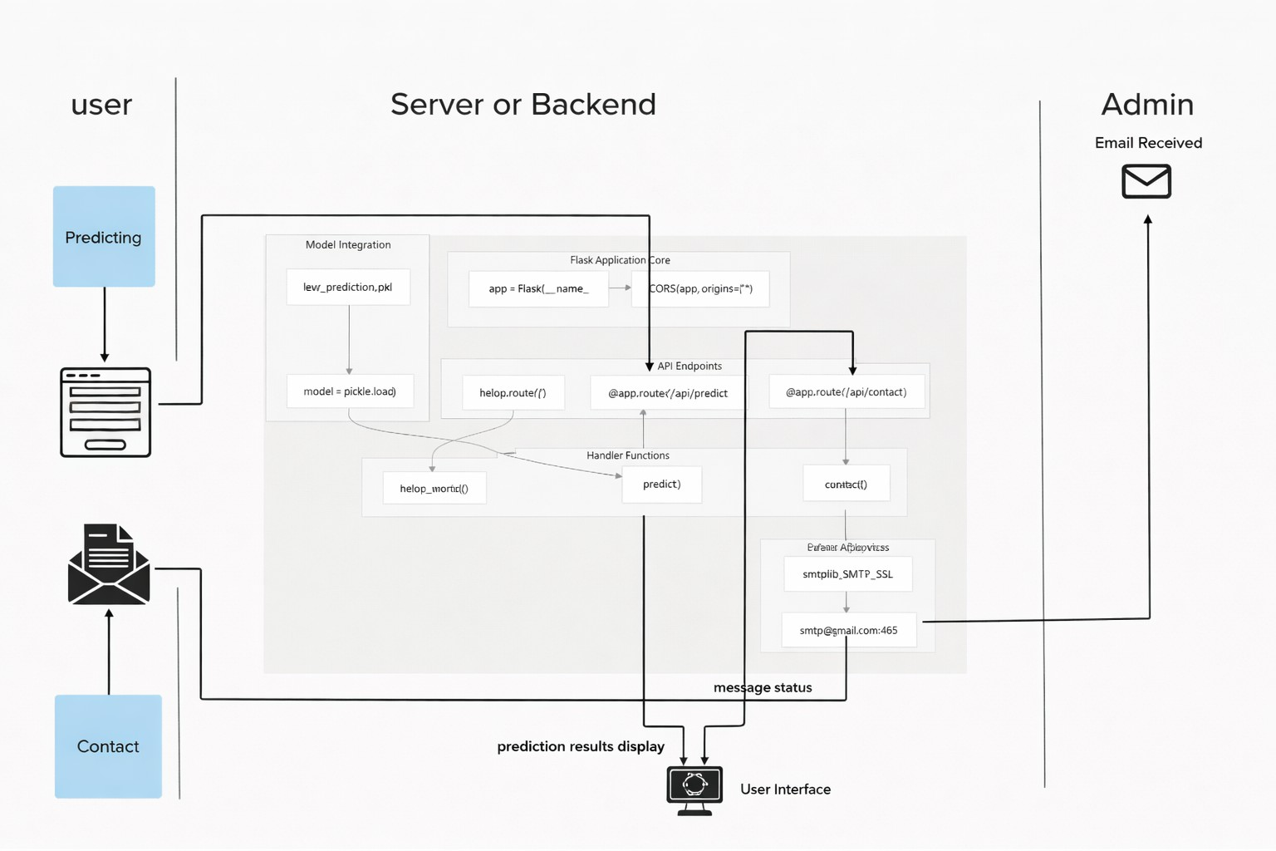
The technical architecture of the proposed system follows a three-tier architecture consisting of the User Interface layer, Backend/Application layer, and Deep Learning Model layer. This architecture ensures modularity, scalability, and ease of maintenance.
The user interacts with the system through a web-based interface to upload retinal fundus images and submit prediction requests. The backend server processes these requests using REST APIs and communicates with the trained deep learning model to generate diabetic retinopathy predictions. Administrative communication is handled through email services for user contact requests.
According to the architecture diagram in the reference PDF (page 2), the system separates user interactions, backend processing, and model inference, which improves system reliability and scalability.

Table-1: Components & Technologies

S.N  o | Component | Description | Technology
1 | User Interface | Web-based user interface for uploading retinal fundus images, viewing prediction results, and contacting the administrator | HTML, CSS,  JavaScript
2 | Application Logic-1 | Backend logic to manage routing, request handling, and REST API endpoints | Python (Flask)
3 | Application Logic-2 | Contact form handler that sends user messages to the administrator via email service | Python smtplib, email.message
4 | Application Logic-3 | Deep learning model prediction handler that preprocesses images, performs inference, and returns results | Flask, NumPy, Pandas
5 | External API-1 | Not applicable in the current version | –
6 | External API-2 | Email service used to send user queries and notifications to the administrator | Google Gmail SMTP
7 | Deep Learning Model | Detects diabetic retinopathy from retinal fundus images using image-based learning | Convolutional Neural Network (TensorFlow / PyTorch)
8 | Infrastructure (Server / Cloud) | Application deployed on local server and cloud platforms; container-ready architecture | Flask, Docker-ready, Localhost / Cloud

Explanation of Components
- The User Interface provides an easy and intuitive way for users to upload images and view predictions.
- Application Logic-1 handles API routing and request processing.
- Application Logic-2 manages user communication through secure email services.
- Application Logic-3 connects the backend with the trained deep learning model and handles image preprocessing and prediction.
- The Deep Learning Model uses CNNs to automatically extract retinal features and classify diabetic retinopathy.
- The Infrastructure layer supports scalable deployment using containerized environments.

Table-2: Application Characteristics

S.N  o | Characteristics | Description | Technology
1 | Open-Source Frameworks | All frameworks and libraries used are open-source | Flask, TensorFlow/PyTorch, Pandas, NumPy, Matplotlib
2 | Security Implementations | Input validation, secure email handling, and backend security headers | Gmail Authentication, Flask-CORS
3 | Scalable Architecture | Backend is modular; deep learning model can be containerized and scaled | 3-tier architecture (Frontend, API, Model)
4 | Availability | Backend API deployable using Docker ensures high availability on cloud platforms | Docker, Flask
5 | Performance | Optimized image preprocessing and fast inference with response time less than 2 seconds | Flask API, optimized CNN model

Summary
The selected technology stack provides a robust foundation for building a scalable, secure, and high-performance diabetic retinopathy detection system. The combination of a
web-based interface, Flask backend, and CNN-based deep learning model ensures accurate medical image analysis and real-time predictions. The architecture supports future enhancements such as cloud deployment, mobile integration, and multi-class disease severity detection.

References
- https://c4model.com/
- https://developer.ibm.com/patterns/ai-powered-backend-system-for-order-processing
-during-pandemics/
- https://www.ibm.com/cloud/architecture
- https://aws.amazon.com/architecture
- https://medium.com/the-internal-startup/how-to-draw-useful-technical-architecture-dia grams-2d20c9fda90d

